assignment #02

Course: CHE 301: Chemical Engineering Thermodynamics
Term: Fall 2025
Professor: Dr. Michael Caracotsios
Office: EIB 244

Cell Phone: (630) 696-0934
E-mail: mcaracot@uic.edu

Names: ___________________________________________
Due Date: Wednesday, September 17th in Class (11:00AM)

INSTRUCTIONS FOR ASSIGNMENT DELIVERY

- Prepare a typed report of your assignment.
- Include this cover page with your name(s) in the report.
- Upload your report as a PDF file by the Due Date and Time on the UIC Blackboard.
- Bring a hard copy of your report as a PDF file by the Due Date and Time in class

- Assignments that are not typed will not be accepted.
- Late Assignments will not be accepted without prior approval.
- You may use the Internet as well as ChatGPT or other public tools as long as you place a written statement about their use in your assignment report

Problem A: Superheated steam is generated in a boiler at and expanded into a High-Pressure Turbine. A slip stream (known as extraction steam) is diverted into a Closed Feed Water Heater (CFWH) to heat the liquid condensate (Stream S8) before it enters the steam generator. The cold extraction steam (Stream S6) is then directed back to the main condenser. The rest of the HP Turbine exhaust is expanded into a steam condensing turbine (CST) to a pressure . This process is known as Regenerative Rankine Cycle with Closed Feed Water Heater (CFWH) and it is very common in modern power plants because it results in substantial reduction of fuel usage and therefor carbon dioxide emissions. A schematic of a typical Regenerative Rankine Cycle with CFWH is shown below:

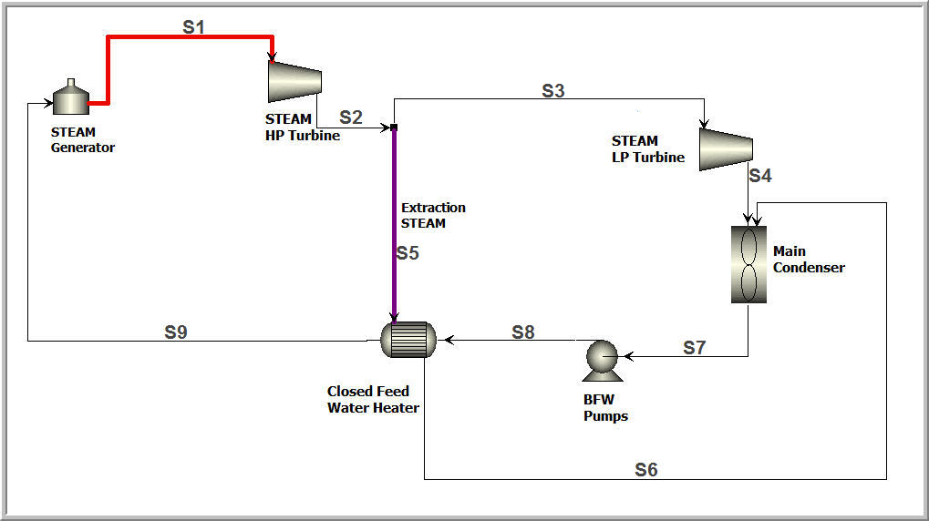

The following operating data are available for this power plant:

- Total power generated from the two turbines: 1000 MW
- HP turbine discharge pressure: 15 bar
- Temperature of Stream S7 (subcooled liquid) 38 deg C
- HP and LP Turbine efficiency: 80%
- Boiling Feed Water (BFW) pump efficiency 70%
- Fuel used: Bituminous Coal with heating value 22 MJ/kg
- Boiler efficiency: 80%
- Temperature of Steam S9 is 5ºC lower than that of stream S6 which is saturated liquid.

Calculate:

- The amount of steam required in MMSCFD
- The amount of Bituminous coal required in kg/s
- The lost work in each equipment of the Regenerative Rankine Cycle
- The thermal and thermodynamic efficiency of the cycle if the goal is power generation
- The emissions of CO2 in gigatons per year.
- Find through research the CO2 emissions per year worldwide in gigatons. Make sure you report the year for which you have found this information

Report Guidelines:

- Prepare detailed analysis of the high- and low-pressure turbines
- Prepare detailed analysis of the Boiling Feed Water pump
- Prepare detailed analysis of the Closed Feed Water Heater
- Prepare a table with the list of all equipment and the lost work associated with each one
- Prepare a full material and energy balance using the ENG Calculations worksheet

